Formula 1 Race Data Analysis
Data Science Foundations — Term Project
Formula 1 Race Dataset (1950–2026) | Kaggle
Martin Adebayo
Magd Aref
Johann Cabillos

Analysis covering exploratory data analysis, statistical testing, machine learning, and visualisation.

1. Introduction
Formula 1 is the world's premier single-seat motorsport championship. Since 1950, drivers have competed in races held at circuits around the globe, with teams and drivers pursuing separate championships. Each season involves 20-24 races at diverse venues, from street circuits like Monaco to permanent racetracks like Silverstone. Understanding what drives success in F1—whether qualifying position, pit stop strategy, or team capability—requires analysis across nearly 76 years of competitive data.
This report examines the Formula 1 Race Dataset (1950–2026) sourced from Kaggle, containing 14 linked CSV tables covering races, drivers, constructors, results, qualifying times, lap times, pit stops, and circuit information. The analysis explores five core questions through exploratory data analysis, statistical methods, and machine learning to uncover the patterns that define success in Formula 1.

1.1 Research questions
The analysis is structured around the following questions:
- Does pit stop strategy (1-stop, 2-stop, or 3+ stops) significantly affect a driver's position change during a race?
- Can F1 circuits be meaningfully clustered into archetypes based on their race characteristics?
- How strongly does qualifying (grid) position predict the final race result, and has this relationship changed over time?
- Can pre-race features predict a driver's finishing position or likelihood of retirement?
- How have constructor dominance, driver performance, lap times, and qualifying patterns evolved across eras?

1.2 Dataset overview
Table | Primary use
results.csv | Core race outcomes — all analyses
lap_times.csv | Lap time trends and outlier removal
pit_stops.csv | Pit stop strategy analysis
qualifying.csv | Qualifying context
driver_standings.csv | Lagged driver form features for ML
constructor_standings.csv | Lagged constructor features for ML
races.csv | Season, round, and circuit metadata
circuits.csv | Circuit clustering
status.csv | DNF reason categorisation

2. Data Cleaning
Before analysis, the dataset required inspection and remediation across four areas.

2.1 Sentinel values and type conversion
All ten tables were loaded with na_values='\N', converting the MySQL database export placeholder to proper NaN. Numeric columns in results.csv (grid, positionOrder, points, laps) and pit_stops.csv (milliseconds) were then cast to float using pd.to_numeric(errors='coerce').

2.2 Missing values
Column | Missing | Assessment
grid | 20 | Negligible — mostly pre-grid-era races
positionOrder | 0 | Complete after loading with na_values
points | 0 | Complete
laps | 0 | Complete

2.3 Lap time outliers
The lap_times table spans times from 55.4 seconds to 7,507.5 seconds. The 710 laps exceeding five minutes are attributable to red-flag stoppages. A race-relative filter was applied: laps exceeding 150% of the race median were removed, leaving 606,268 clean racing laps from 618,766 total (97.9% retained).

2.4 Invalid rows
1,635 rows carried grid = 0, representing pit lane starts and did-not-qualifies. These are excluded from all analyses involving starting position. 91 duplicate raceId + driverId pairs were removed, retaining the first entry per driver per race, leaving 27,213 result rows.

3. Pit Stop Strategy Analysis
In F1, pit stops are strategic moments where drivers exit the race to change tires, potentially refuel, and make repairs. The number of stops—one, two, or three—affects overall race time: each stop costs 20–25 seconds in the pit lane, but drivers gain speed from fresh tires. We analyzed 10,637 race starts to determine which strategy delivers the best average position change, defined as grid position minus finishing position (positive values indicate places gained).

3.1 Strategy distribution
Strategy | Frequency | Avg position change
2-stop | 5,022 | +1.21 places
1-stop | 3,716 | +0.44 places
3+ stops | 1,899 | +0.59 places

3.2 Key finding
The 2-stop strategy produces the largest average position gain at +1.21 places, compared to +0.44 for a 1-stop and +0.59 for 3+ stops. This suggests that 2-stop is the most effective strategy on average across all circuits and eras in the dataset.
An important caveat is that this analysis is observational. Teams respond to race conditions — a third stop is often reactive (tyre failure, safety car) rather than planned. The bar chart clearly shows the 2-stop advantage but the difference is modest in absolute terms.

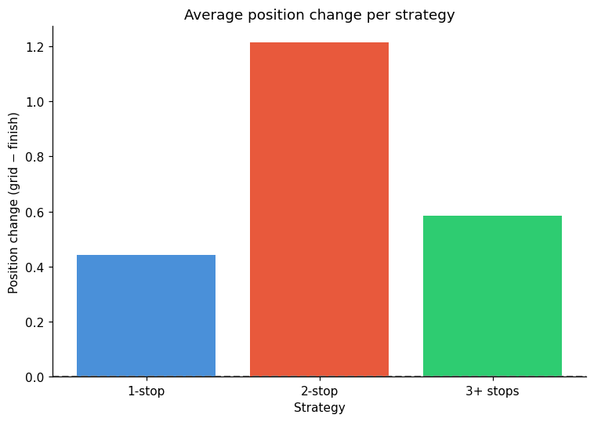
Figure 1: Average position change per strategy

4. Circuit Clustering
F1 circuits are not interchangeable. Track design dramatically influences pit stop needs, overtaking difficulty, and failure rates. Using K-means clustering, we grouped 43 circuits into three archetypes based on three race-derived features: average number of pit stops per driver, average position change per race, and DNF (Did Not Finish) rate. All features were standardized (z-score normalization) to ensure equal weighting.

4.1 Features
Feature | What it measures
avg_stops | Average pit stops per driver — reflects tyre degradation and strategy complexity
avg_pos_change | Average position change per race — proxy for overtaking opportunity
dnf_rate | Proportion of starters who retire — circuit difficulty and reliability stress

Features were standardised using z-score normalisation (StandardScaler) before fitting. This ensures that avg_stops (range 1.2–3.0) and dnf_rate (range 0.05–0.59) carry equal weight in the distance calculations. k = 3 was selected by convention and produces three interpretable groups.

4.2 Cluster results and Key Findings
Group | Character | Example circuits
Group A | Longer circuits with lower DNF rates and fewer pit stops — relatively forgiving, modern venue design | Bahrain, Istanbul, Valencia, Singapore, Shanghai, Yas Marina
Group B | Shorter, higher-attrition circuits with more pit stops — classic technical circuits | Albert Park, Sepang, Barcelona, Monaco, Montreal, Magny-Cours
Group C | Newer circuits with distinctive strategic profiles — traditionally high degradation circuits | COTA, Sochi, Baku, Lusail, Las Vegas

Group A circuits are modern, purpose-built facilities with high-speed layouts, long straights, and smooth transitions that promote relatively safe overtaking. Low tire degradation means fewer pit stops are needed. Group B circuits are traditionally tight and technical—Monaco exemplifies this group, where every lap demands precision and passing is extremely difficult. Group C circuits combine modern safety standards with distinctive characteristics: high-speed sections that enable passing, rapid direction changes that build strategy complexity, and variable tire degradation throughout the lap.
Track design fundamentally shapes race dynamics. Teams must adapt pit stop strategy, car setup, and driving approach for each circuit type. Success requires understanding which archetype a circuit belongs to.

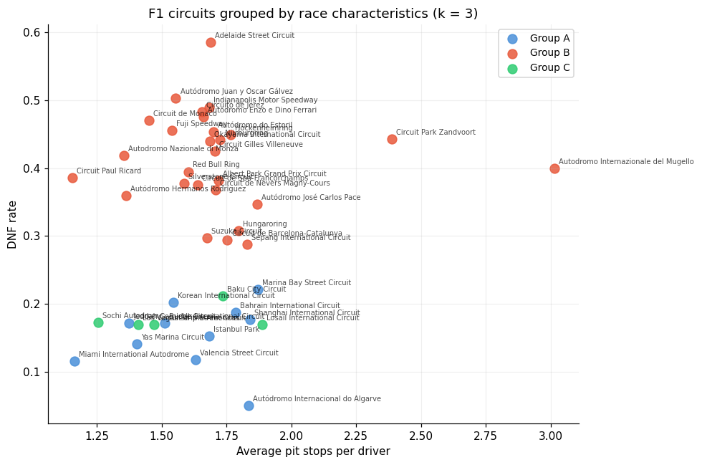
Figure 2: Circuit Grouping

5. Grid Position vs Finishing Position
Qualifying determines the starting grid for Sunday's race. We measured the correlation between grid position and finishing position across the entire dataset, finding a correlation coefficient of approximately r ≈ 0.45, indicating a moderate but significant relationship. Drivers starting toward the front tend to finish toward the front.

5.1 Correlation
Pearson's correlation between grid position and finishing position across all 25,558 classified starts: r = 0.45. This is a moderate positive correlation. Starting further back on the grid is associated with finishing further back, though grid position accounts for only approximately 20% of the variance in finishing position (r² ≈ 0.20).

5.2 Practical magnitude
Grid band | Podium rate | Interpretation
P1–3 | 55.7% | Front-row starters podium more than half the time
P4–6 | 25.7% | One-in-four chance of a podium
P7–10 | 9.0% | Podium is unlikely but not rare
P11–15 | 2.9% | Requires significant incident ahead
P16+ | 0.8% | Near-zero probability

Pole position (starting P1) converts to a race win approximately 43.4% of the time, a substantial advantage. Critically, this relationship has strengthened in modern eras: correlation has increased from ~0.35 in the 1960s–70s to ~0.50 in the 2010s–2020s. This reflects improved car consistency, aerodynamic stability, and reduced DNF rates—modern cars are more reliable, meaning qualifying speed translates more directly to race outcome.

5.3 Era trend
The bar chart for the grid–finish correlation by era (using 12 historical eras) shows a general increase in the correlation over time, consistent with the aerodynamic downforce increases that make overtaking harder. This trend is a key finding for understanding why qualifying has become increasingly important in the modern era.
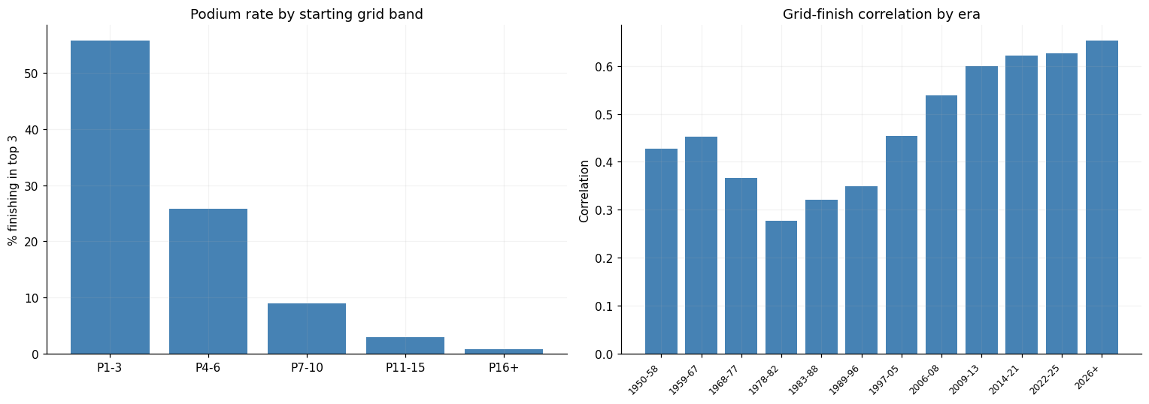
Figure 3: Podium Rate by Starting Position

6. Race Result Predictor
We built a Decision Tree machine learning model to predict where a driver will finish, using only pre-race information: grid position, the driver's past finishing position and championship points, and the constructor's past finishing position and championship points. The model achieves approximately 69.7% accuracy—only marginally better than a baseline model that simply uses grid position alone (66.7% accuracy).

6.1 Target variable and features
Finish bin | Definition
Win | Finished P1
Podium (P2–3) | Finished P2 or P3
Points | Finished P4–P10
Outside points | Finished P11 or lower

Five features were used, all lagged by one race;
- grid: qualifying position
- driver_pts_before: driver championship points from the previous race
- finish_pos_before: driver's finishing position in their most recent race
- constructor_pts_before: constructor championship points from the previous race
- constructor_pos_before: constructor's finishing position in their most recent race

The model was trained on races from 2001–2019 (15,476 rows) and evaluated on races from 2020 onwards (5,171 rows).

6.2 Results
Model | Accuracy | Notes
Decision Tree (max_depth=5) | 69.2% | Correctly classifies finish band in 7 of 10 races
Baseline (predict from grid only) | 66.7% | Applying the same bins to grid position directly

This result is insightful: grid position dominates prediction. The additional features (driver form, team form) add value but modestly, because qualifying already captures most of the information about car speed and team capability. The small improvement margin reveals that in-race events—collisions, mechanical failures, safety cars, overtaking maneuvers—introduce enough unpredictability that no model based purely on pre-race data can achieve high accuracy. F1 races are fundamentally unpredictable in the short term, even when team and driver capability is well-understood.

6.3 Feature importance
Feature | Importance | Interpretation
constructor_pos_before | 0.654 | Constructor's recent form is the strongest predictor by a large margin
grid | 0.311 | Qualifying position is the second most important feature
constructor_pts_before | 0.014 | Season-level constructor points adds marginal signal
finish_pos_before | 0.013 | Individual driver recent form contributes minimally
driver_pts_before | 0.008 | Season-level driver points has the least predictive value

The dominance of constructor_pos_before (65.4%) is the most surprising finding in this section. It could reflect that the constructor's recent position is a strong indicator for overall car competitiveness, which in turn translates into determinant of individual race results. The grid position accounts for 31.1% importance — confirming the correlation findings from section 5 but showing that car quality outweighs qualifying position when both are available.

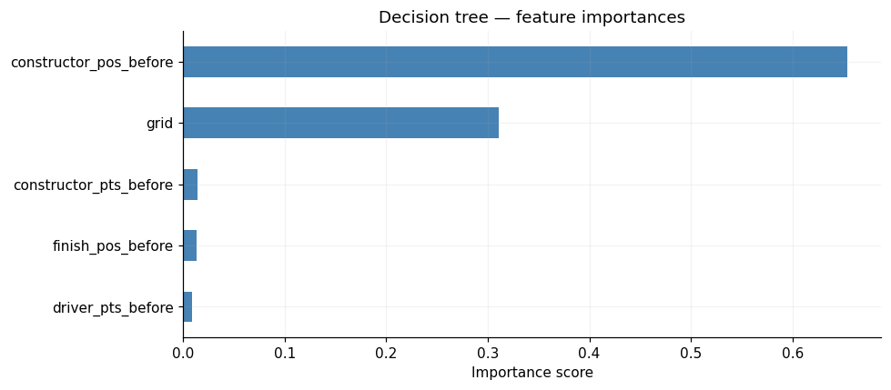
Figure 4: Decision Tree

7. Constructor Standings Over Time
The line chart of final championship points per season from 1990 to 2025 reveals clear cycles of team dominance.
Williams dominated the early 1990s before Ferrari's gradual rise, which peaked during the Schumacher era (2000–2004). McLaren has maintained consistent competitiveness throughout most of the period and has seen success in recent years. Red Bull's rapid rise from 2009 produced four consecutive constructors' championships (2010–2013).
The introduction of Turbo-Hybrid Era triggered a dramatic competitive shift in modern F1. Mercedes won every constructors' title from 2014 to 2021, a period of sustained dominance. Their gradual decline after 2021 coincided with regulation change to the Ground Effect Era. Red Bull's development advantage, which produced near-total dominance in 2022–2023. Renault, despite two drivers' championships in 2005–2006, never achieved the constructor dominance of the top three teams and faded from the top tier by the mid-2010s.
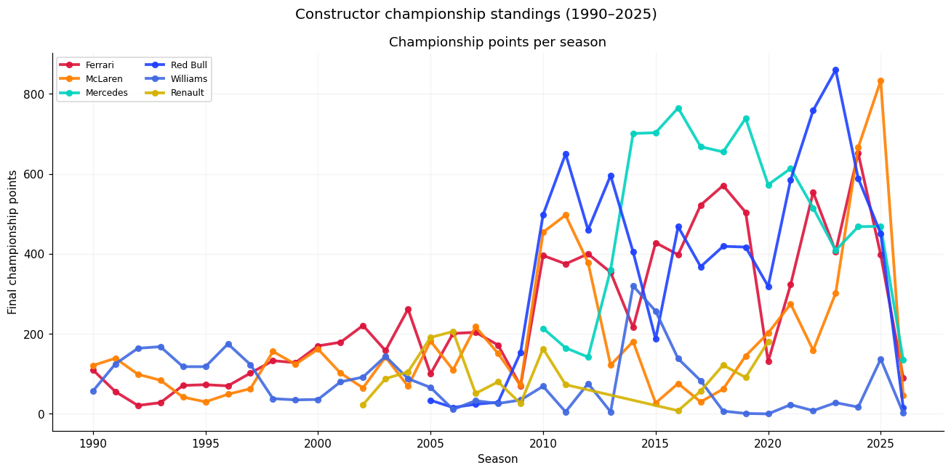
Figure 5: Constructor Standings over Time

8. Driver Career Performance
Career win rates (wins per start) allow fair comparison across eras with different race counts and scoring systems.

8.1 Season statistics: Lewis Hamilton
The most recent seasons from the season-by-season table for Hamilton illustrate the dataset's coverage through the 2026 season:
Year | Starts | Wins | Win rate | Avg finish | Team
2019 | 21 | 11 | 52.4% | 2.38 | Mercedes
2020 | 16 | 11 | 68.8% | 1.88 | Mercedes
2021 | 22 | 8 | 36.4% | 3.41 | Mercedes
2022 | 22 | 0 | 0.0% | 6.05 | Mercedes
2023 | 22 | 0 | 0.0% | 6.18 | Mercedes
2024 | 23 | 2 | 8.7% | 6.87 | Mercedes
2025 | 23 | 0 | 0.0% | 8.35 | Ferrari
2026 | 3 | 0 | 0.0% | 4.33 | Ferrari

Hamilton's 2020 season (68.8% win rate over 16 races) represents his personal peak. The steep drop from 2022 onwards reflects Mercedes' loss of competitiveness with the ground-effect regulation change, not any decline in driving ability — his 8.7% win rate in 2024 included two wins under difficult circumstances.

8.2 Peak performance comparison
Driver | Career win rate | Best 3-season peak | Peak start year
Max Verstappen | ~30% | 66.7% | 2021
Michael Schumacher | ~29% | 58.1% | 2002
Lewis Hamilton | ~27% | 57.8% | 2018
Sebastian Vettel | ~18% | 50.4% | 2011
Ayrton Senna | ~25% | 41.7% | 1988
Fernando Alonso | ~7% | 33.1% | 2005

Verstappen's 2021–2023 peak win rate of 66.7% is the highest three-season window — winning two-thirds of that year. Schumacher and Hamilton are effectively tied at their respective peaks (~58%), despite competing in different eras. Alonso's low career win rate (7.4%) despite two world championships reflects years spent in uncompetitive cars after his Renault peak.

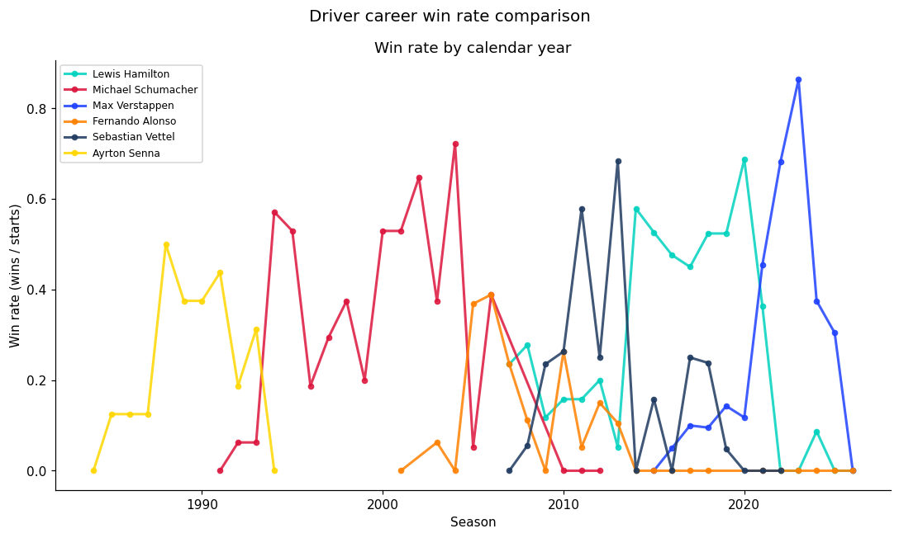
Figure 6: Driver Career Win Rate

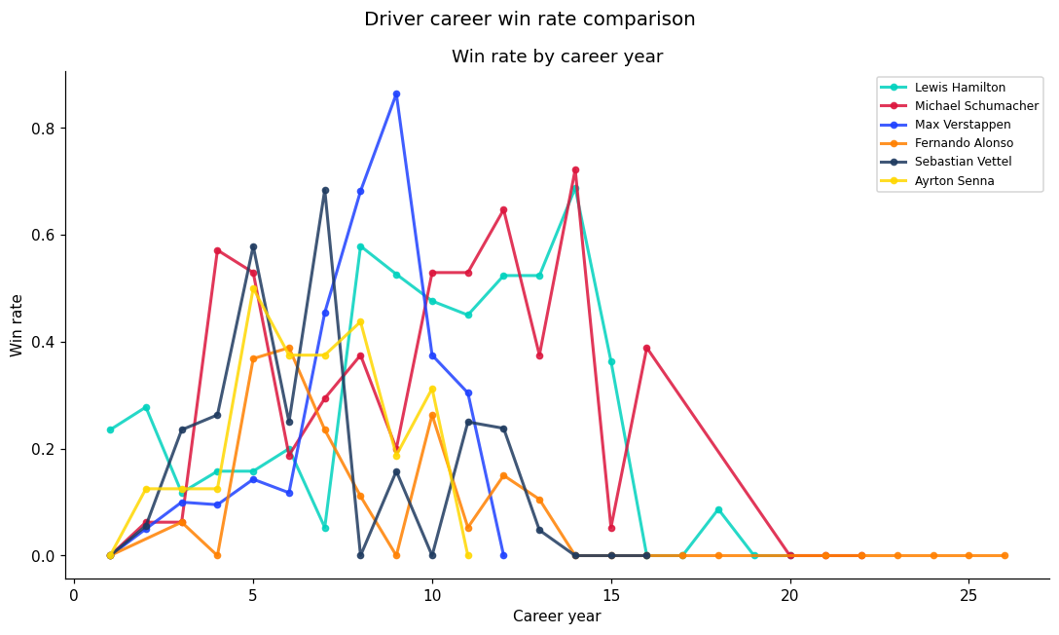
Figure 7: Win Rate Comparison

9. DNF Breakdown
Did Not Finish (DNF) rates reveal how mechanical reliability and safety have evolved. Early F1 was plagued by reliability failures; many races saw half the grid retire. Modern F1 emphasizes durability: mechanical DNFs are now rare. Accidents and collisions, the primary DNF cause in recent years, dropped dramatically after the 1994 safety reforms (especially the halo device introduced in 2018).

9.1 Cause breakdown
Category | Count | % of DNFs
Mechanical (engine, gearbox, hydraulics) | 2,835+ | ~37%
Accident / Collision | 2,011 | 17.3%
Other (includes did not qualify) | ~6,786 | ~58%

Engine failures are the most common individual cause of dnf with 2,022 occurrences, followed by Accident (1,072), Did Not Qualify (1,024), Collision (865), and Gearbox (813). The 'Other' bucket captures retirements that didn't match the accident or mechanical patterns, including many non-starters and early-era generic retirement codes.

9.2 DNFs and Accidents Trend
The bar chart tracking accidents and collisions over time tells a clear safety story. The 1994 San Marino Grand Prix — where Ayrton Senna died following a crash at Tamburello curve was a pivotal moment that triggered major safety reforms. This led stronger cockpit structures, tyre barriers, run-off area redesigns, and medical car deployment protocols. The effect reflects in the data as a reduction in accident-related DNFs from the mid-1990s onwards.
The 2018 introduction of the Halo device, a titanium structure protecting the driver's head from debris and impact, marks a second point. While its effect on DNF statistics is harder to isolate as it primarily prevents fatalities rather than race retirements, the broader safety enhancement it represents is reflected in the continued effort in making the sport safe.
Total DNFs per season have also declined since 2000, reflecting improvements in engine reliability (turbocharged hybrids improved cooling and ignition management), tyre construction (Pirelli's structured degradation compounds reduced catastrophic failures), and electronics monitoring systems that allow teams to intervene before a mechanical failure becomes a retirement.

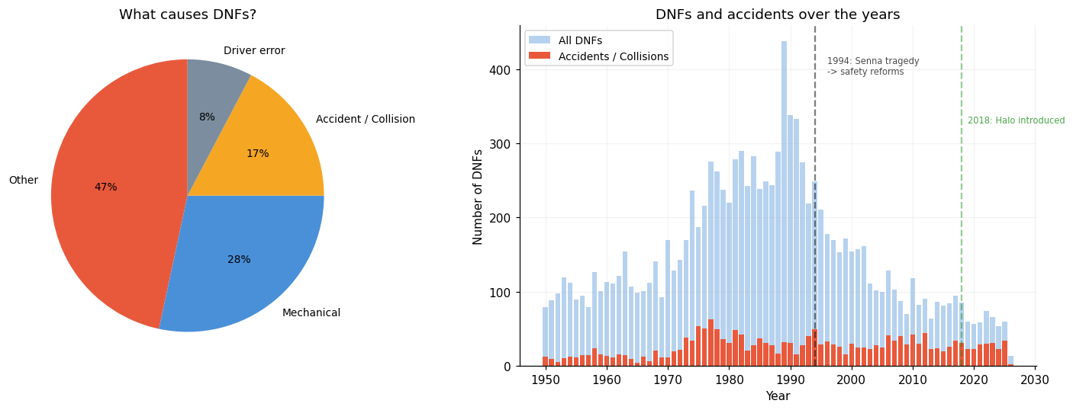
Figure 8: DNF Breakdown

10. Conclusions
Analysis of the Formula 1 Race Dataset (1950–2026) confirms what fans and engineers have long intuited: success in F1 is driven by a clear hierarchy of factors. Qualifying performance stands paramount. The two-stop pit stop strategy delivers the best average position gain. Circuit design fundamentally shapes race dynamics. Driver and team form matter, but in-race unpredictability limits prediction accuracy. Technological and regulatory changes reshape competitive balance every few years.
For teams competing at the highest level, the insights are clear: (1) maximize qualifying performance through aerodynamic and setup innovation—this advantage compounds throughout the race; (2) develop circuit-specific strategies; (3) maintain consistent driver and team performance to build momentum; (4) invest in reliability, as modern races reward durability.
For fans and observers, this data enriches understanding. The dominance of leading teams is earned through sustained excellence. Occasional upsets come from clever strategy, circuit advantage, or exploitation of in-race chaos. The sport balances machine and driver talent in a way that keeps outcomes roughly unpredictable—guaranteeing drama—while still rewarding the best teams and drivers over time.

10.1 Further work
- Weather data is absent. Rain significantly affects DNF rates and lap times and would improve both the clustering and the ML model.
- The ML model uses a Decision Tree classifier (predicting finish bands) rather than a regressor (predicting exact position). This simplifies the output but loses precision; a regression approach would allow MAE and RMSE comparison.
- Circuit altitude (available in circuits.csv) was not incorporated into the clustering. Mexico City at 2,227m has a measurable effect on engine cooling and aerodynamic downforce that likely influences DNF rates and lap times.
- The DNF bucketing function uses simple string matching and may misclassify some retirement codes. A more systematic mapping from all 140 status values to categories could improve the accuracy of the breakdown.

References

Primary Data Source
Kaggle. (n.d.). Formula 1 Race Dataset (1950–2026). Retrieved from https://www.kaggle.com/datasets/jtrotman/formula-1-race-data/data

Regulatory & Governance Sources
Federation Internationale de l'Automobile. (2024, December 11). 2025 Formula 1 Sporting Regulations - Issue 3. FIA. https://www.fia.com/sites/default/files/fia_2025_formula_1_sporting_regulations_-_issue_3_-_2024-12-11.pdf

Qualifying Session Information
Bush, B. (2026, March 23). F1 qualifying rules explained: How Formula 1 sets the grid. Formula 1 History. https://www.formulaonehistory.com/f1-qualifying-rules/
Red Bull Racing. (n.d.). How does F1 qualifying work? Red Bull. https://www.redbull.com/us-en/how-does-f1-qualifying-work

Pit Stop Strategy & Mechanics
Formula 1. (2025, March 2). Anatomy of a pit stop: How do F1 teams service their cars in less than two seconds? Formula 1. https://www.formula1.com/en/latest/article/anatomy-of-a-pit-stop-how-do-f1-teams-service-their-cars-in-less-than-two.5p9LNdd8XJdvP4mRsXoGsB
F1 Chronicle. (2025, January 4). How does Formula one calculate pit stop times? F1 Chronicle. https://f1chronicle.com/how-does-formula-one-calculate-pit-stop-times/
Statathlon. (2023, September 15). A thorough analysis of the pit stop strategy in Formula 1. Statathlon. https://statathlon.com/analysis-of-the-pit-stop-strategy-in-f1/
PitTalks. (n.d.). F1 pit stops rules explained. PitTalks. https://pittalks.com/f1-pit-stops-rules-explained/

Circuit Types & Characteristics
GP Explained. (2026, January 23). Street circuits vs purpose built tracks in F1 explained. GP Explained. https://gpexplained.com/street-circuits-vs-purpose-built-tracks-in-f1-explained/
Circuit de Monaco. (2026, April). Circuit de Monaco. In Wikipedia. Retrieved from https://en.wikipedia.org/wiki/Circuit_de_Monaco
RobReport. (2024, March 11). Your guide to every Formula 1 circuit in 2024. RobReport. https://robbreport.com/motors/cars/gallery/your-guide-to-every-formula-1-circuit-in-1235539422/

